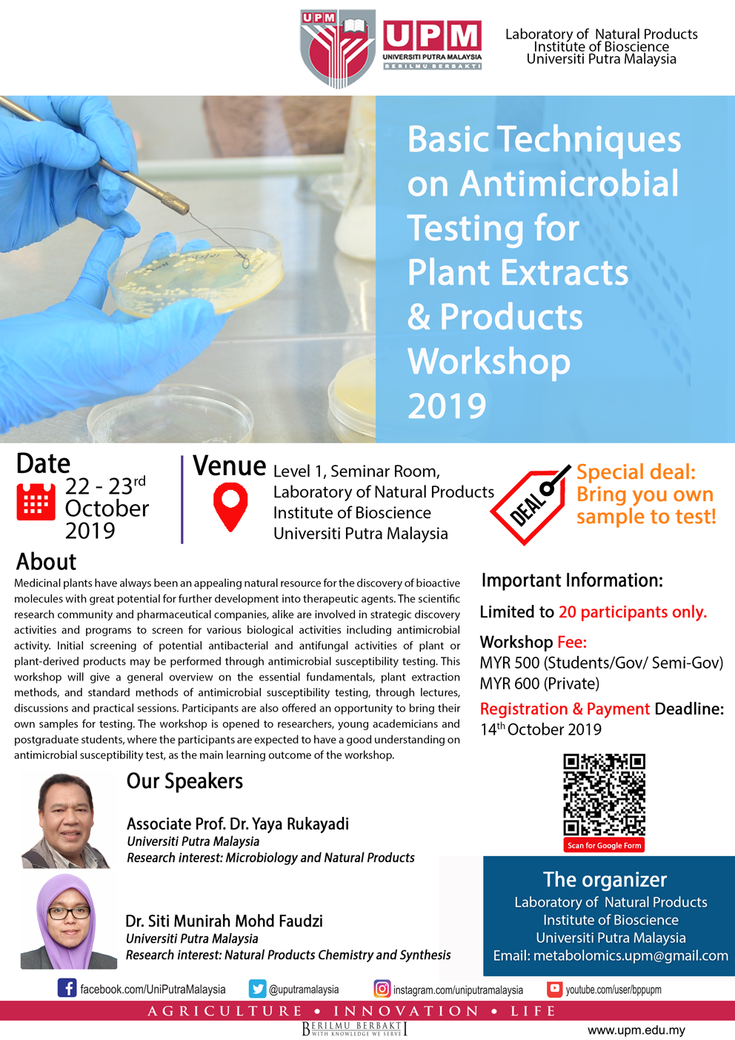
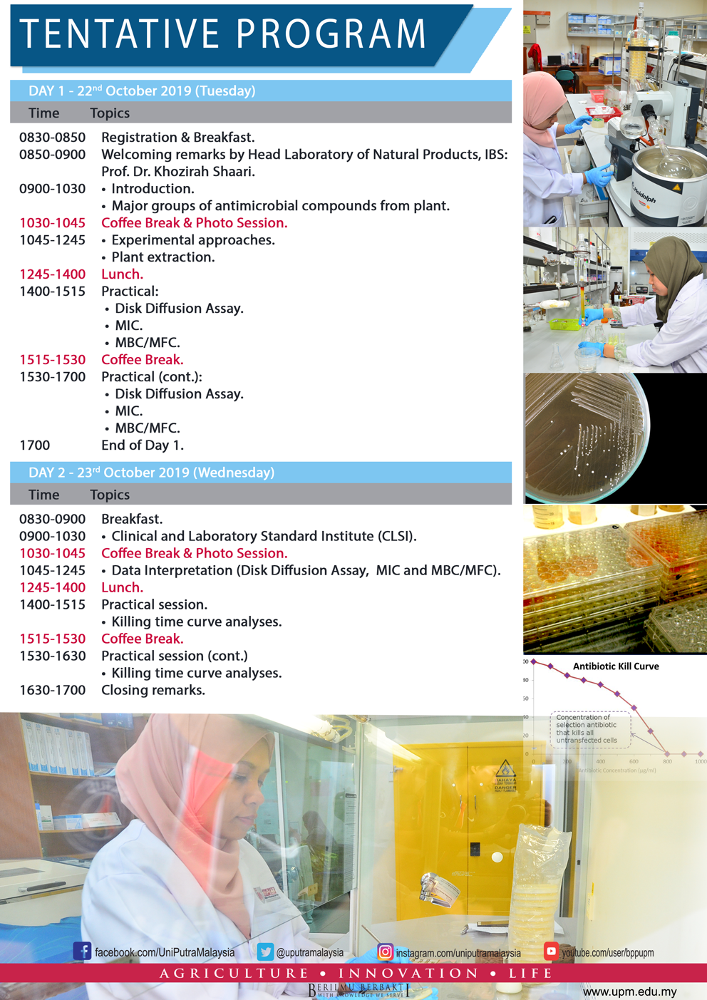

Registration form
PARTICIPANT DETAILS:
(Please type or write your particulars in BLOCK letters and tick ‘√’ as appropriate)
Name and Title:
Organization:
Position:
Mailing Address:
Contact Number : | Office |  | Mobile |  | Fax
E-mail:
Vegetarian: | Yes No
Registration fee: | MYR500.00 (Student/Gov/Semi-Gov)  MYR600.00 (Private sector)  Modes of Payment:  No. Method Please Tick  1. Pelarasan Antara PTJ using grant (UPM Staff / Researcher). Please provide your vote number. Vote No.: _____________ (compulsory)  2. Bank draft/cheque should be made payable to: BENDAHARI UNIVERSITI PUTRA MALAYSIA Payment Reference: Antimicrobial Workshop 2019 and Participant's Full Name.  3. Electronic Funds Transfer (EFT) – FOR LOCAL PARTICIPANTS ONLY Beneficiary Name: KIRA-KIRA AM UPM Bank Name: CIMB Bank Bank Address: CIMB UPM Branch, 43400 UPM Serdang, Selangor Malaysia Account No. : 80-0215196-3 SWIFT Code: CIBBMYKL  Notes:  - No refund for cancellation.  - Please email (metabolomics.upm@gmail.com) the completed registration form together with the undertaking letter (cheque/LO) or payment proof (EFT) before 14th October 2019.
Deadline for Registration: | 14th October 2019 or immediately after 20 seats were booked.  (which comes first)
Deadline for Payment: | 14th October 2019.

Signature: _______________________ Date: _____________________________________

Please submit the completed registration form and the proof of payment to:
The Secretariat
Basic Techniques on Antimicrobial Testing for Plant Extracts and Products 2019
Laboratory of Natural Products,
Institute of Bioscience, Universiti Putra Malaysia,
43400 UPM Serdang, Selangor, Malaysia.
E-mail: metabolomics.upm@gmail.com

