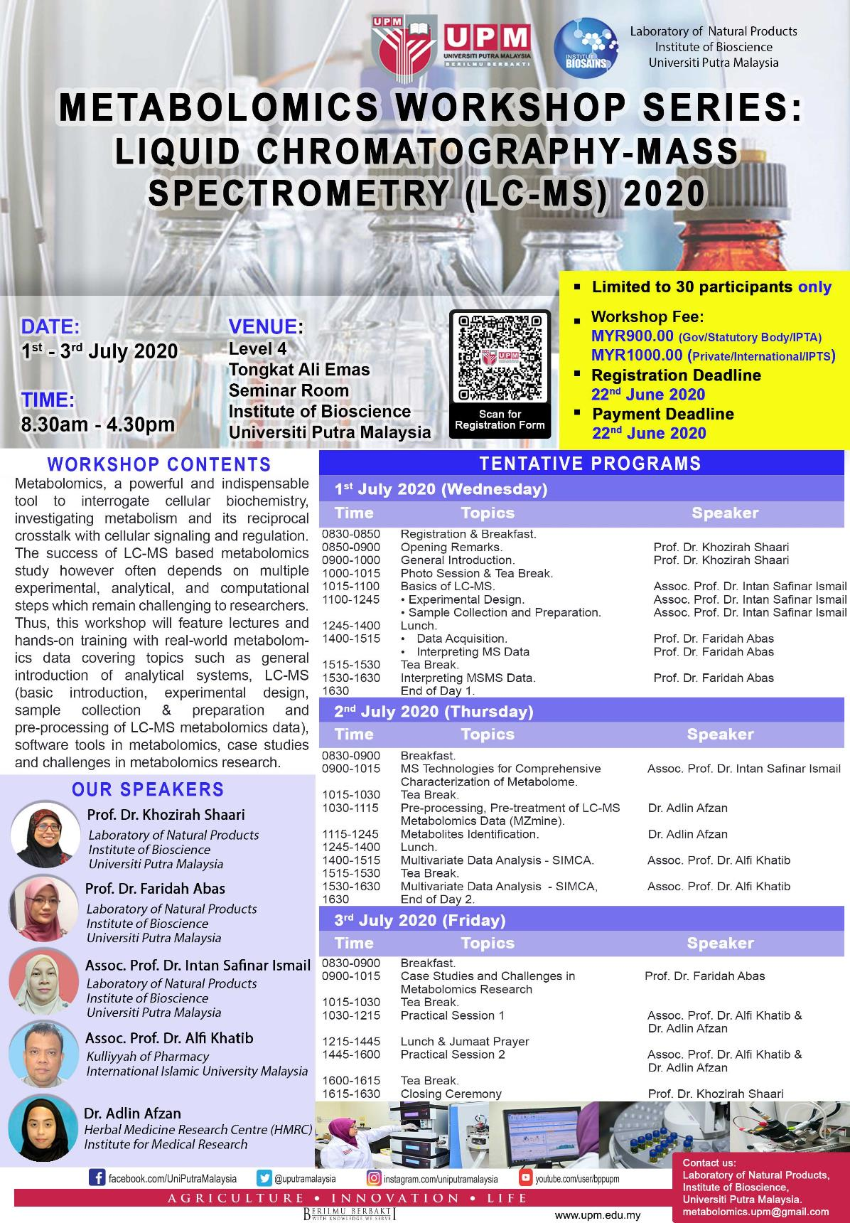

Registration form
PARTICIPANT DETAILS:
(Please type or write your particulars in BLOCK letters and tick ‘√’ as appropriate)
NAME AND TITLE:
ORGANIZATION:
POSITION:
MAILING ADDRESS:
CONTACT NUMBER : | OFFICE |  |  |  | MOBILE |  |  |  | FAX
E-MAIL:
VEGETARIAN: | YES |  |  | NO
REGISTRATION FEE: | MYR900.00 (Gov/Statutory Body/IPTA)  MYR1000.00 (Private/International/IPTS)  Modes of Payment:  No. Method Please Tick  1. Pelarasan Antara PTJ using grant (only for UPM student, staff or researcher). Please provide your vote number. Vote No.: _____________ (compulsory)  2. Bank draft/cheque should be made payable to: Beneficiary Name: KIRA-KIRA AM UPM Bank Name: CIMB Bank Bank Address: CIMB UPM Branch, 43400 UPM Serdang, Selangor Malaysia Account No. : 80-0215196-3 Payment Reference: Metabolomics Workshop Series: LCMS and Participant's Full Name.  3. Electronic Funds Transfer (EFT) – For Local Participants Only Beneficiary Name: KIRA-KIRA AM UPM Bank Name: CIMB Bank Bank Address: CIMB UPM Branch, 43400 UPM Serdang, Selangor Malaysia Account No. : 80-0215196-3 SWIFT Code: CIBBMYKL  Notes:  - No refund for cancellation.  - Please email (metabolomics.upm@gmail.com) the completed registration form together with the undertaking letter (cheque/LO) or payment proof (EFT) before 22nd June 2020.
Deadline for Registration: | 22nd June 2020 or immediately after 30 seats were booked.  (which comes first)
Deadline for Payment: | 22nd June 2020.

Signature: _______________________ Date: ________________________________

Please submit the completed registration form and the proof of payment to:
Metabolomics Workshop Series: Liquid Chromatography-Mass Spectrometry 2020
Laboratory of Natural Products, Institute of Bioscience, Universiti Putra Malaysia,
43400 UPM Serdang, Selangor, Malaysia.
E-mail: metabolomics.upm@gmail.com

